15. Scenario: You are a data analyst working for a social media platform. As part of your analysis,

you have a dataset containing user interaction data, including the number of likes received by each

post. Your task is to develop a Python program that calculates the frequency distribution of likes

among the posts.

Question: Develop a Python program to calculate the frequency distribution of likes among the

posts?

Code:

import pandas as pd

import matplotlib.pyplot as plt

df = pd.read_csv(r"C:\Users\jampa\Downloads\user_interaction_data.csv")

like_distribution = df['likes'].value_counts().sort_index()

print("Frequency Distribution of Likes:")

print(like_distribution)

# Optional: Visualize

like_distribution.plot(kind='bar', figsize=(10, 6), title='Frequency Distribution of Likes')

plt.xlabel('Number of Likes')

plt.ylabel('Number of Posts')

plt.grid(axis='y', linestyle='--', alpha=0.7)

plt.tight_layout()

plt.show()

output:

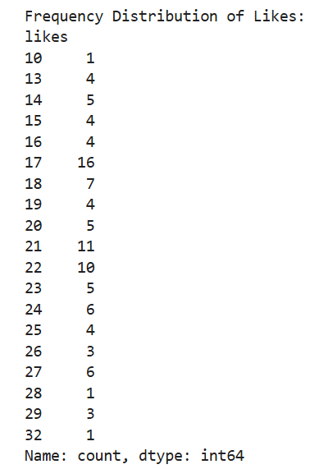

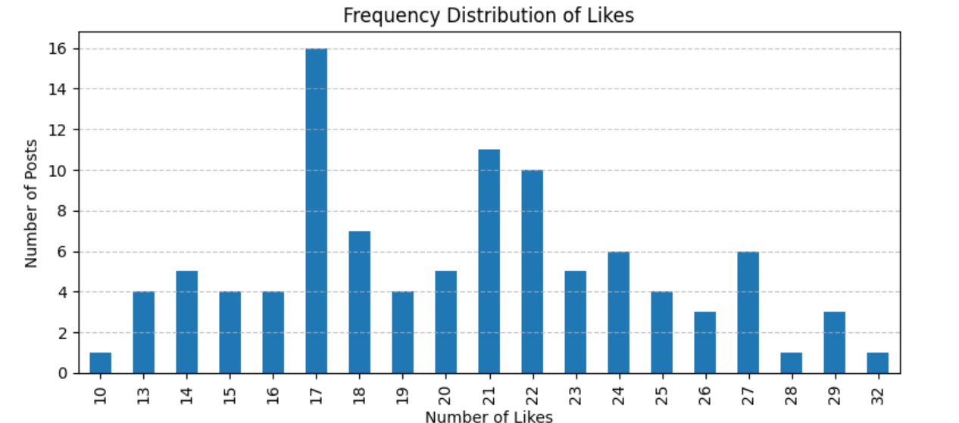

Dataset:

|  |  |  |
| --- | --- | --- |
| post_id | likes |  |
| post_1 | 23 |  |
| post_2 | 15 |  |
| post_3 | 21 |  |
| post_4 | 25 |  |
| post_5 | 15 |  |
| post_6 | 17 |  |
| post_7 | 19 |  |
| post_8 | 21 |  |
| post_9 | 17 |  |
| post_10 | 19 |  |
| post_11 | 16 |  |
| post_12 | 21 |  |
| post_13 | 21 |  |
| post_14 | 17 |  |
| post_15 | 22 |  |
| post_16 | 14 |  |
| post_17 | 17 |  |
| post_18 | 17 |  |
| post_19 | 21 |  |
| post_20 | 21 |  |
| post_21 | 13 |  |
| post_22 | 18 |  |
| post_23 | 25 |  |
| post_24 | 17 |  |
| post_25 | 24 |  |
| post_26 | 23 |  |
| post_27 | 24 |  |
| post_28 | 18 |  |
| post_29 | 26 |  |
| post_30 | 18 |  |
| post_31 | 17 |  |
| post_32 | 23 |  |
| post_33 | 26 |  |
| post_34 | 14 |  |
| post_35 | 24 |  |
| post_36 | 24 |  |
| post_37 | 20 |  |
| post_38 | 17 |  |
| post_39 | 27 |  |
| post_40 | 19 |  |
| post_41 | 16 |  |
| post_42 | 17 |  |
| post_43 | 28 |  |
| post_44 | 24 |  |
| post_45 | 27 |  |
| post_46 | 17 |  |
| post_47 | 16 |  |
| post_48 | 19 |  |
| post_49 | 14 |  |
| post_50 | 29 |  |
| post_51 | 20 |  |
| post_52 | 32 |  |
| post_53 | 20 |  |
| post_54 | 17 |  |
| post_55 | 21 |  |
| post_56 | 10 |  |
| post_57 | 27 |  |
| post_58 | 14 |  |
| post_59 | 22 |  |
| post_60 | 16 |  |
| post_61 | 18 |  |
| post_62 | 22 |  |
| post_63 | 13 |  |
| post_64 | 17 |  |
| post_65 | 22 |  |
| post_66 | 20 |  |
| post_67 | 22 |  |
| post_68 | 23 |  |
| post_69 | 29 |  |
| post_70 | 18 |  |
| post_71 | 17 |  |
| post_72 | 25 |  |
| post_73 | 20 |  |
| post_74 | 27 |  |
| post_75 | 18 |  |
| post_76 | 26 |  |
| post_77 | 22 |  |
| post_78 | 21 |  |
| post_79 | 13 |  |
| post_80 | 21 |  |
| post_81 | 22 |  |
| post_82 | 23 |  |
| post_83 | 18 |  |
| post_84 | 22 |  |
| post_85 | 22 |  |
| post_86 | 13 |  |
| post_87 | 17 |  |
| post_88 | 27 |  |
| post_89 | 24 |  |
| post_90 | 21 |  |
| post_91 | 15 |  |
| post_92 | 17 |  |
| post_93 | 22 |  |
| post_94 | 27 |  |
| post_95 | 17 |  |
| post_96 | 25 |  |
| post_97 | 15 |  |
| post_98 | 29 |  |
| post_99 | 21 |  |
| post_100 | 14 |  |
|  |  |  |
|  |  |  |
|  |  |  |
|  |  |  |
|  |  |  |
|  |  |  |
|  |  |  |
|  |  |  |
|  |  |  |
|  |  |  |
|  |  |  |
|  |  |  |
|  |  |  |
|  |  |  |
|  |  |  |
|  |  |  |
|  |  |  |
|  |  |  |
|  |  |  |
|  |  |  |
|  |  |  |
|  |  |  |
|  |  |  |
|  |  |  |
|  |  |  |
|  |  |  |
|  |  |  |
|  |  |  |
|  |  |  |
|  |  |  |
|  |  |  |
|  |  |  |
|  |  |  |
|  |  |  |
|  |  |  |
|  |  |  |
|  |  |  |
|  |  |  |
|  |  |  |
|  |  |  |
|  |  |  |
|  |  |  |
|  |  |  |
|  |  |  |
|  |  |  |
|  |  |  |
|  |  |  |
|  |  |  |
|  |  |  |
|  |  |  |
|  |  |  |
|  |  |  |
|  |  |  |
|  |  |  |
|  |  |  |
|  |  |  |
|  |  |  |
|  |  |  |
|  |  |  |
|  |  |  |
|  |  |  |
|  |  |  |
|  |  |  |
|  |  |  |
|  |  |  |
|  |  |  |
|  |  |  |
|  |  |  |
|  |  |  |
|  |  |  |
|  |  |  |
|  |  |  |
|  |  |  |
|  |  |  |
|  |  |  |
|  |  |  |
|  |  |  |
|  |  |  |
|  |  |  |
|  |  |  |
|  |  |  |
|  |  |  |
|  |  |  |
|  |  |  |
|  |  |  |
|  |  |  |
|  |  |  |
|  |  |  |
|  |  |  |
|  |  |  |
|  |  |  |
|  |  |  |
|  |  |  |
|  |  |  |
|  |  |  |
|  |  |  |
|  |  |  |
|  |  |  |
|  |  |  |
|  |  |  |
|  |  |  |
|  |  |  |
|  |  |  |
|  |  |  |
|  |  |  |
|  |  |  |
|  |  |  |
|  |  |  |
|  |  |  |
|  |  |  |
|  |  |  |
|  |  |  |
|  |  |  |
|  |  |  |
|  |  |  |
|  |  |  |
|  |  |  |
|  |  |  |
|  |  |  |
|  |  |  |
|  |  |  |
|  |  |  |
|  |  |  |
|  |  |  |
|  |  |  |
|  |  |  |
|  |  |  |
|  |  |  |
|  |  |  |
|  |  |  |
|  |  |  |
|  |  |  |
|  |  |  |
|  |  |  |
|  |  |  |
|  |  |  |
|  |  |  |
|  |  |  |
|  |  |  |
|  |  |  |
|  |  |  |
|  |  |  |
|  |  |  |
|  |  |  |
|  |  |  |
|  |  |  |
|  |  |  |
|  |  |  |
|  |  |  |
|  |  |  |
|  |  |  |
|  |  |  |
|  |  |  |